English title (Times New Roman, 18pt)
Author¹, Author¹, Author²
AFFILIATION¹, AFFILIATION²
E-mail: dummy@dummy.co.jp

Abstract This is a placeholder abstract for a conference paper template. An abstract should concisely summarize the study’s objective, methodology, key findings, and significance in 50–100 words. It should be written clearly and precisely, avoiding unnecessary details. A well-structured abstract typically includes an introduction to the research topic, a brief description of the approach, main results, and potential implications. When using this template, replace this text with a meaningful abstract relevant to your research. Ensure that the content is informative, engaging, and aligned with the paper’s core contributions.
Keywords sample, sample, sample, sample, 5 words at maximum

- Introduction
This study proposes a novel approach to address a specific research problem. While numerous methods have been explored in recent years, certain challenges remain unresolved. In this paper, we identify the limitations of existing techniques and introduce an improved method to overcome them. The proposed approach is designed to enhance accuracy and efficiency.

- Related work
Several approaches relevant to this study have been proposed in the past. While existing research has shown promising results, issues such as computational efficiency and accuracy persist. This section reviews major related studies, highlights their limitations, and clarifies the positioning of our proposed method.

- Proposed method
To overcome the limitations of previous methods, we introduce a new approach that enhances both efficiency and accuracy. Our method builds upon existing techniques while incorporating novel elements to improve performance. The following sections provide a detailed explanation of the algorithm and its key features.

- Experiments
To evaluate the effectiveness of the proposed method, we conducted experiments using multiple datasets. We compared our approach with existing techniques in terms of accuracy and computational efficiency. This section describes the experimental setup, evaluation metrics, and a detailed comparison of the results.
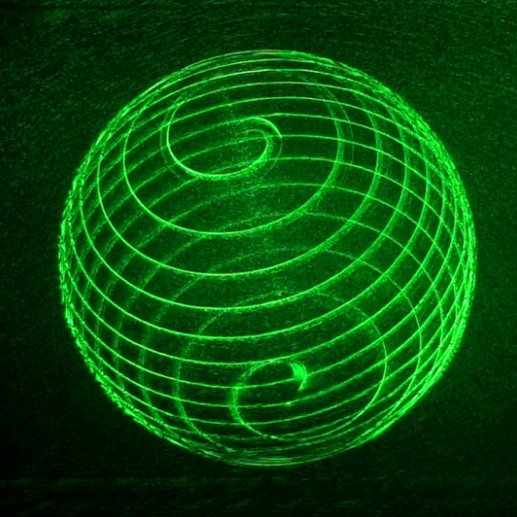
Fig. 1 Optically reconstructed image

- Discussion
We analyze the experimental results and discuss the effectiveness of the proposed method. A comparison with conventional approaches highlights the improvements in accuracy and processing time. Additionally, we address the limitations of our approach and suggest areas for future research.

- Conclusion
In this paper, we proposed a novel method and demonstrated its effectiveness through experiments. Our approach achieved superior performance compared to existing methods. Future work will focus on further optimization and exploring additional applications for the proposed technique.

References
- T. Nishitsuji, T. Shimobaba, T. Kakue, D. Arai, and T. Ito, "Simple and fast cosine approximation method for computer-generated hologram calculation," Opt. Express 23(25), 32465–32470 (2015).

